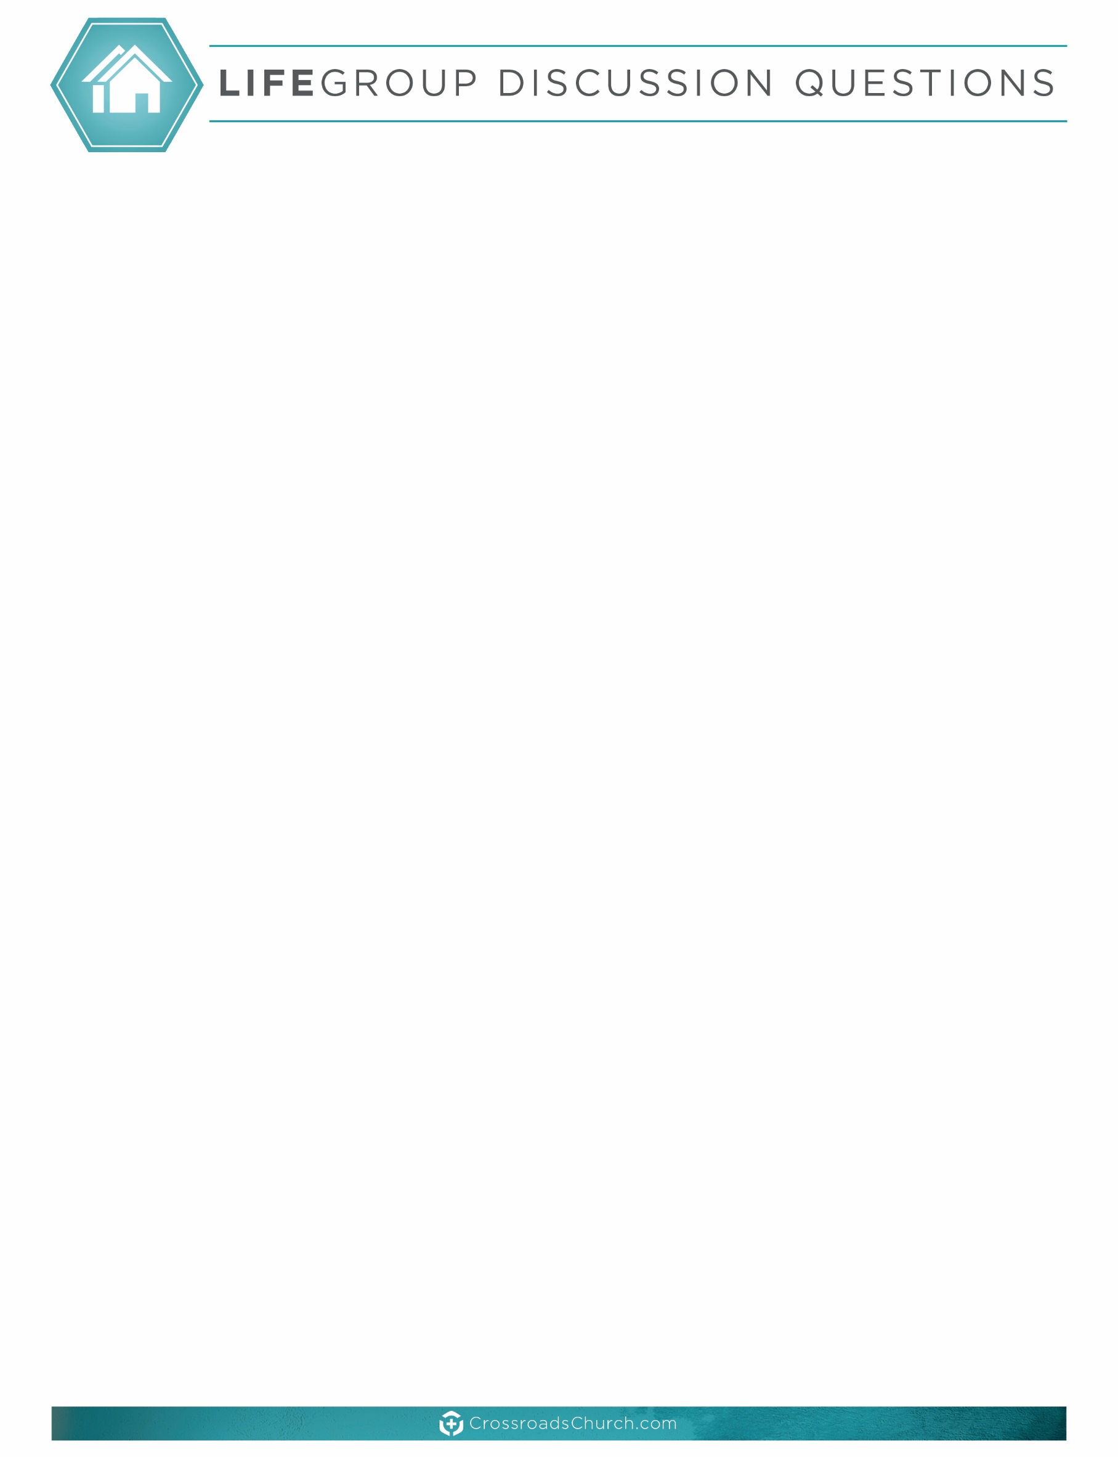

**GUIDELINES:** LIFE Group Discussion Questions are meant to be a tool used to help guide your time together. You may or may not fit all areas and questions into your time. Additional resources such as the LIFE Group Video Question can be found each week at: [www.crossroadschurch.com/Ministries](http://www.crossroadschurch.com/Ministries) under ‘LIFE Group Resources’.

**Enjoy your time and let God lead you!**

* **KICKING IT OFF:** If you could live anywhere on this planet and take everything that you love with you, where would you choose to live?

**MEMORY VERSE***: “*Let all that you do be done in love.” 1 Corinthians 16:14 (NASB)

**GROUP DISCUSSION:**

1. In this week’s sermon, Pastor Chuck compared having boundaries to a “NO TRESPASSING” sign. Where are your no trespassing signs currently? Where could your life benefit from putting such signs in place?
2. Being manipulated is a sign that people are not honoring your “NO TRESPASSING” sign. Share a time that you or someone you knew was manipulated. What did you learn from it?
3. We learned about squatters in the sermon this week- people who have invaded your life and will not get out. Do you have squatters in your life? What are some boundaries that you can create to get them out?
4. As parents we must raise our children to know that they can set boundaries. What are some ways that you can teach children to set boundaries? (This applies to young and adult children)
5. Often times trespassing occurs when we are controlled by fear. Fear comes in many forms- fear of hurting people’s feelings, abandonment, their anger, being ashamed, being seen as selfish, fear of guilt, being seen as unspiritual. Which of these fears do you struggle with the most? Why? Read Isaiah 41:10 and Psalm 118:6.
6. Trespassing can also occur in our lives through the evil of abuse and addiction. Read Proverbs 22:3. Is abuse occurring in your personal life? Is there an addiction that needs your attention today? What are some boundaries that need to be set so that you can have victory over this abuse or addiction?
7. We are responsible for what is inside our property line. We choose how we will react to our feelings, how we will behave, and what we will believe. Read Galatians 6:7-10. What are you currently reaping and sowing in your life? Is that leading closer to God or farther from God?

**GOING DEEPER PERSONALLY:**

This week commit to working on one of the following areas that pertains to you- abuse, addiction, manipulation, and choices. What are some practical steps that you can take to set up a boundary or get help in the area that you are struggling with? What is holding you back from being free and living a prosperous life? Be diligent in prayer asking the Lord for guidance, freedom and victory in these areas.

**“Boundaries” LIFE Group Discussion Questions for September 9/10, 2017**